**NF24l01 FOURTH TEST: Ack payload**

**Procedure:**

1. Connect the transmitter NRF first

2. Upload the Ack payload code

3. Reduce the 2000 millisecond delay as low as possible.

4. The output will be as shown

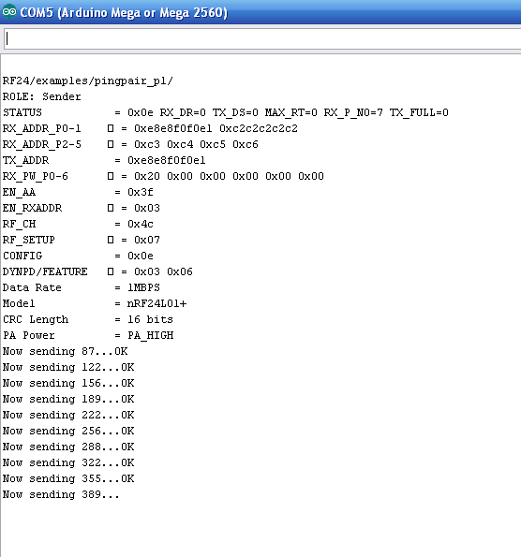

5. Now once you get the shown output connect the receiver side NRF.

6.Upload the same Ack payload code to it.

7. The output will be as shown

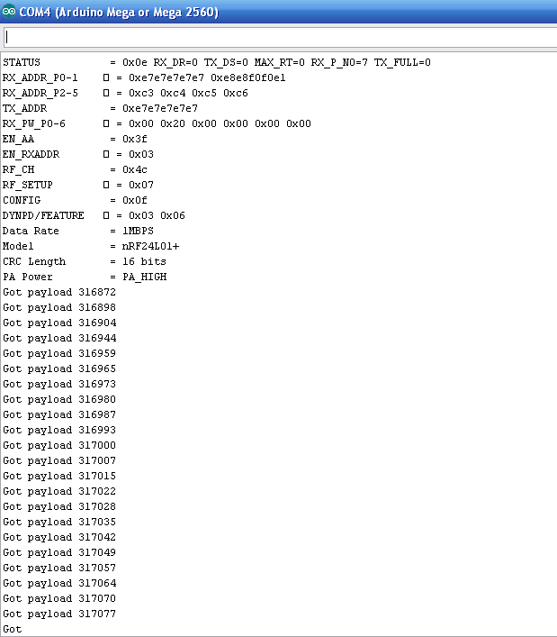

8. Now the transmitter side output will be

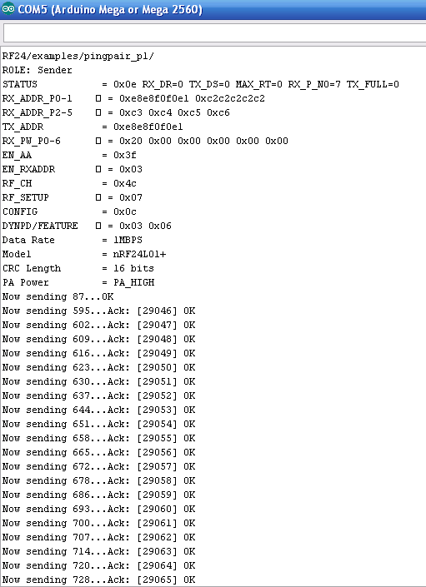

**References:**

You can find the code here <http://maniacbug.github.io/RF24/pingpair_pl_8pde-example.html>

**Note:**

1. If you don’t get the output as same as above check the PIN connections in both arduino and CODE.
2. The PIN connections used in the link provided above are for arduino UNO board.
3. If you use another recheck the pin connections for your board here <https://arduino-info.wikispaces.com/Nrf24L01-2.4GHz-HowTo>